ANNEX 2B
VIABILITY PHASE 3
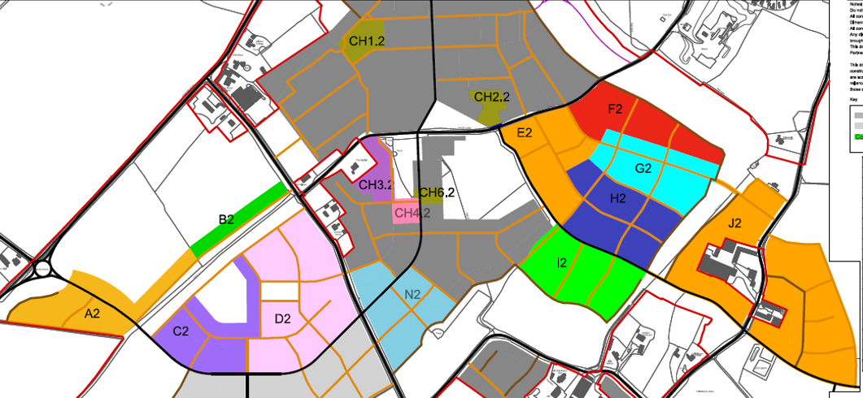
H2
J2
J2
I2
G2
F2
E2

- Land Parcel E2 (89 units)
- Land Parcel F2 (73 units)
- Land Parcel G2 (82 units)
- Land Parcel H2 (103 units)
- Land Parcel I2 (56 units)
- Land Parcel J2 (197 units)
- Total 600 Units

