ANNEX 2C
VIABILITY PHASE 4
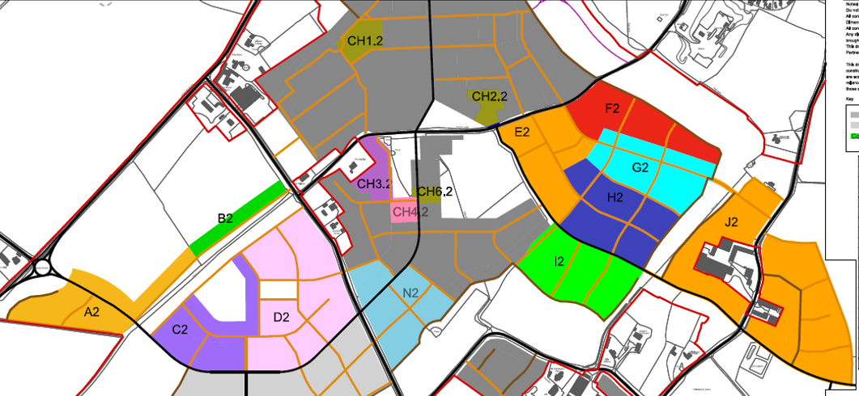
CH
N2
D2
C2
B2
A2
I2

- Land Parcel I2 (26 units)
- Land Parcel N2 (104 units)
- Land Parcel C2 (99 units)
- Land Parcel D2 (184 units)
- Land Parcel A2 (51 units)
- Land Parcel B2 (13 units)
- Land Parcels CH (47 units)
- Total 524 units

